# Conditional Distribution

## **What is a Conditional Distribution?**

A conditional distribution is a [probability distribution](https://www.statisticshowto.datasciencecentral.com/probability-distribution/) for a **sub-population**. In other words, it shows the [probability](https://www.statisticshowto.datasciencecentral.com/probability-and-statistics/probability-main-index/)that a randomly selected item in a sub-population has a characteristic you’re interested in. For example, if you are studying eye colors (the [population](https://www.statisticshowto.datasciencecentral.com/what-is-a-population/)) you might want to know how many people have blue eyes (the sub-population). Conditional distributions are easier to find with the help of a table.

# Example

James is interested in the relationship between weather conditions and train delays. For a year, James records the conditions each day as well as whether this train arrives on time or is delayed. Here are his results:

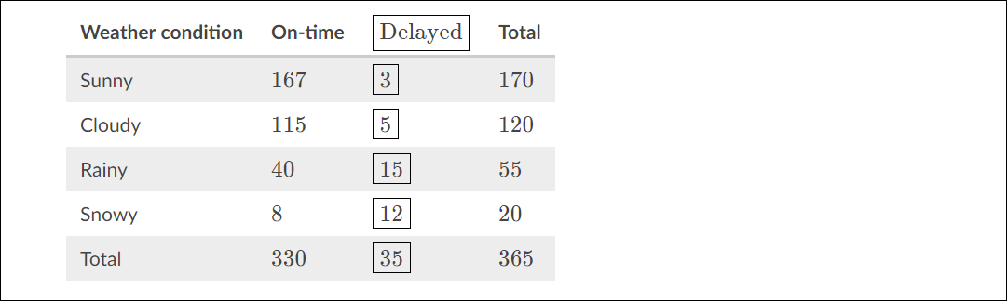

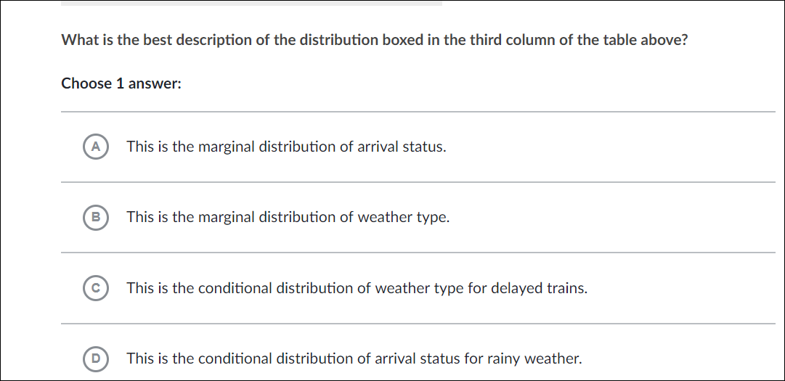

## Variable

The boxed column shows frequencies of different weather types (sunny, cloudy, rainy, snowy), not of different arrival statuses.

Hint #2**2 / 3**

## Marginal vs. conditional distribution

The given distribution describes the frequency of each weather condition, given that the train is delayed.

Since we are looking at the frequencies for each weather condition only for delayed trains, and not all trains (shown in the total column), this is considered a conditional distribution.

**Hint #33 / 3**

## Answer

**This is the conditional distribution of weather type for delayed trains.**